5050 RGB LED Development Board

<https://learn.adafruit.com/adafruit-neopixel-uberguide>

* Basic connection: <https://learn.adafruit.com/adafruit-neopixel-uberguide/basic-connections>
* Sample Connection with BIG Arduino

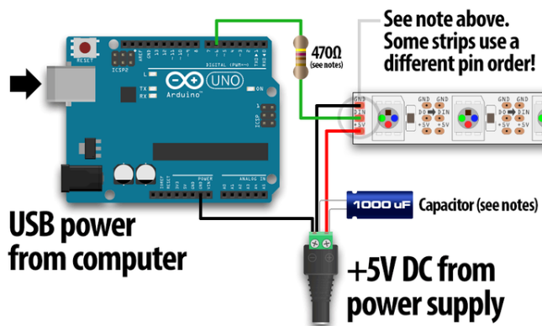

* Add 300 to 500 Ohm in between microcontroller data pin & LED data pin
* Optionally for large power source add a capacitor 0.1 uf – 1000 uf across the + and – terminals
* Using Lithium Polymer Battery <https://learn.adafruit.com/adafruit-neopixel-uberguide/power#step-5>
* **ALWAYS** 
  + **Connect** 
    - **1. Ground**
    - **2. +5V / + 3.7V**
    - **3. Data Pin +5V / + 3.3V**
  + **Disconnect**
    - **1. Data Pin**
    - **2. +5V / + 3.7V**
    - **3. Ground**
* Library & Examples
  + Install: <https://learn.adafruit.com/adafruit-neopixel-uberguide/arduino-library-installation>
  + You will find examples from File -> Examples -> Adafruit NeoPixel
* Test
  + Set the number of LEDs on your Strip/Neopixels
  + Set the Digital PIN number
  + Run Strandtest / Simple /